**ENCORE 1.0 PRE-QUALIFIER CHALLENGE**

**IPD Group No. – 31**

**Team –**

Tanishq Patel 60002220151 TE

Varun Choudhary 60002220220 TE

Soham Shenoy 60002231062 SE

Swayam Bhosale 60002230140 SE

**Youtube Link** - <https://youtu.be/eubQz41UsOA>

**Problem Statement –** Buck Converter design and simulation

|  |  |
| --- | --- |
| **Vin** | 24V |
| **Vout** | 5V |
| **Iin** | 1A |
| **Efficiency** | 90% |

**Calculated Values:**

Calculations in the next page.

|  |  |  |  |
| --- | --- | --- | --- |
| **D** | 0.1875 | **ΔiL** | 0.864A |
| **Iout** | 4.32A | **LCritical** | 4.12µH |
| **Fs** | 100KHz | **LRipple** | 42.3µH |
| **L** | 50µH |
| **C** | 18.2pF |

L > **LCritical**

L > **LRipple**

Switch and Diode: Voltage rating > 24V

Current Rating > 5A

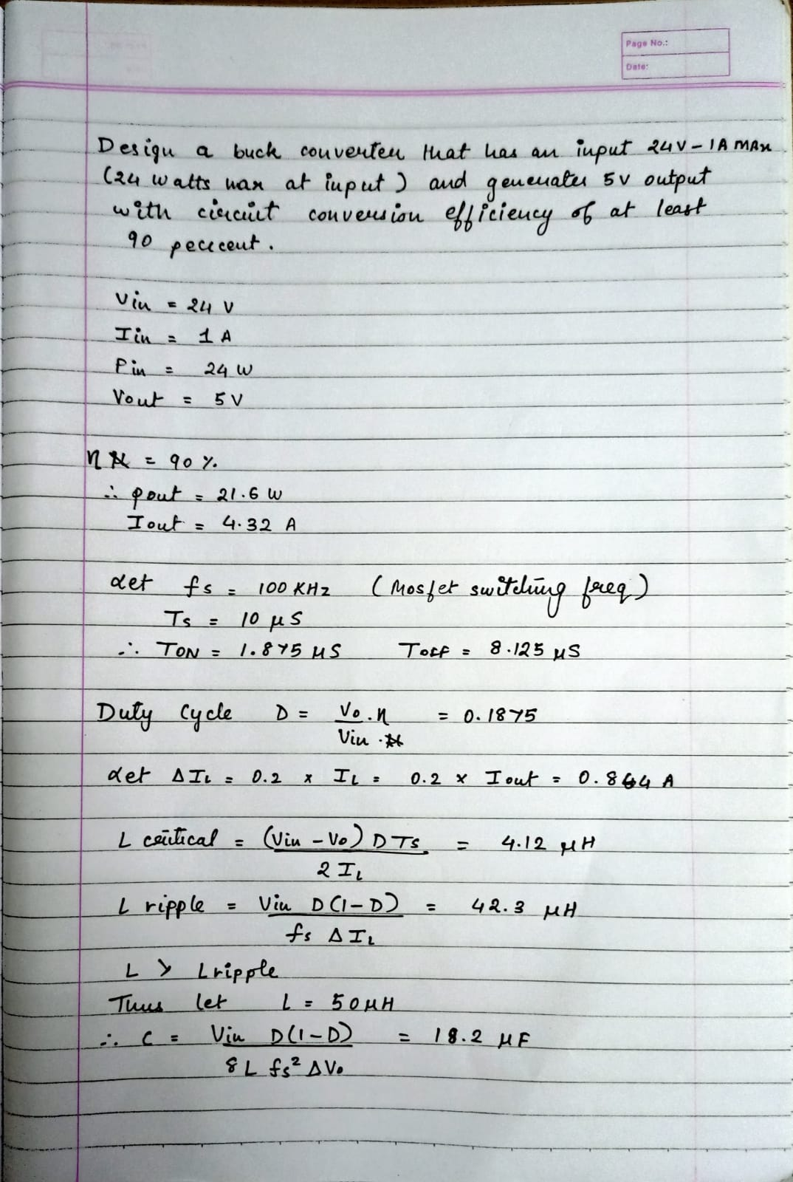

**Simulation:**

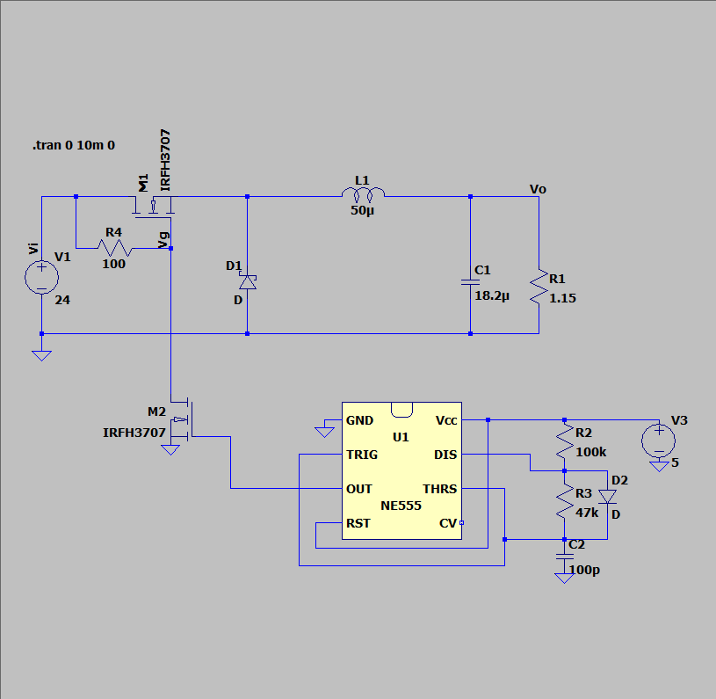

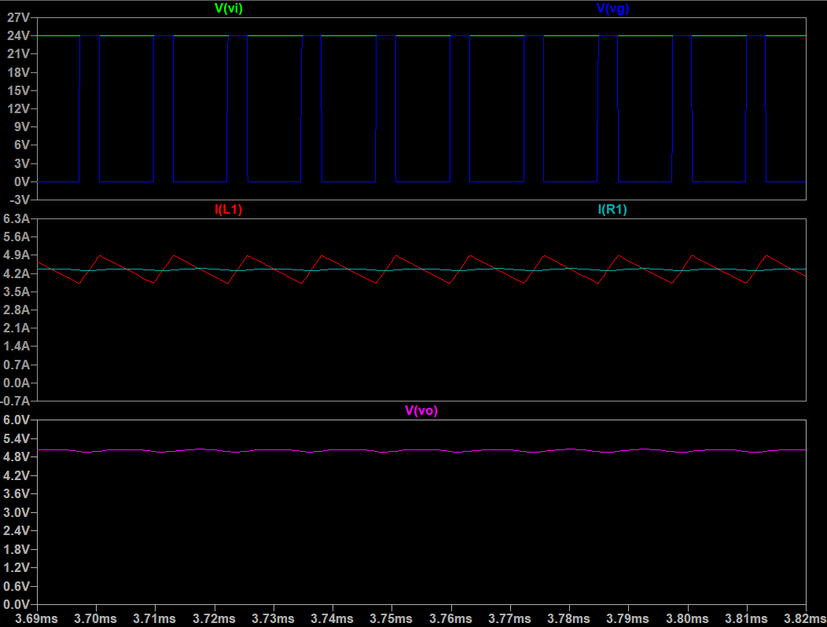

**Schematic and PCB:**

